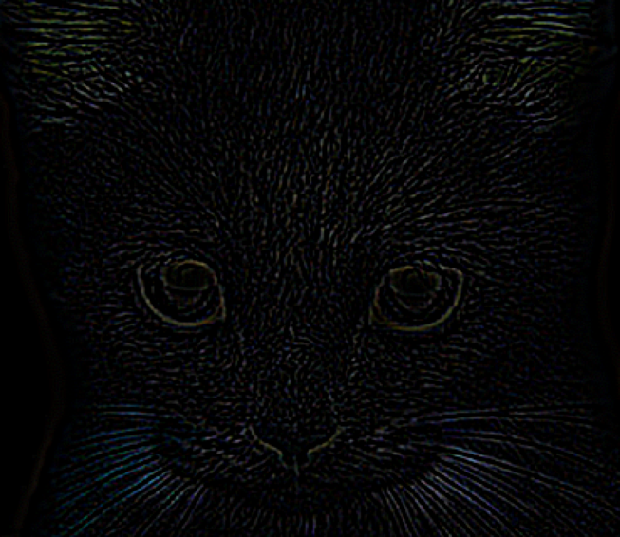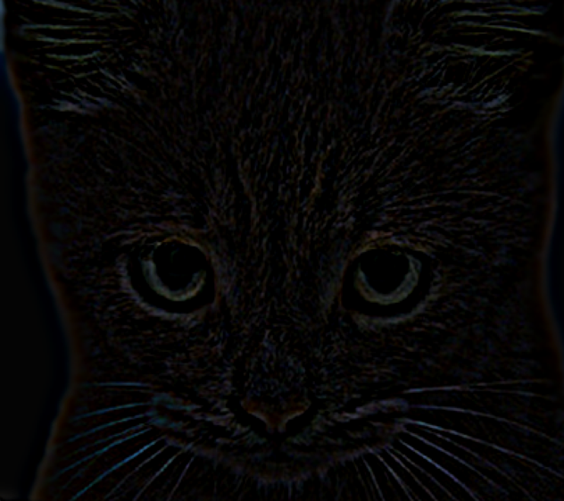

LOG suggested

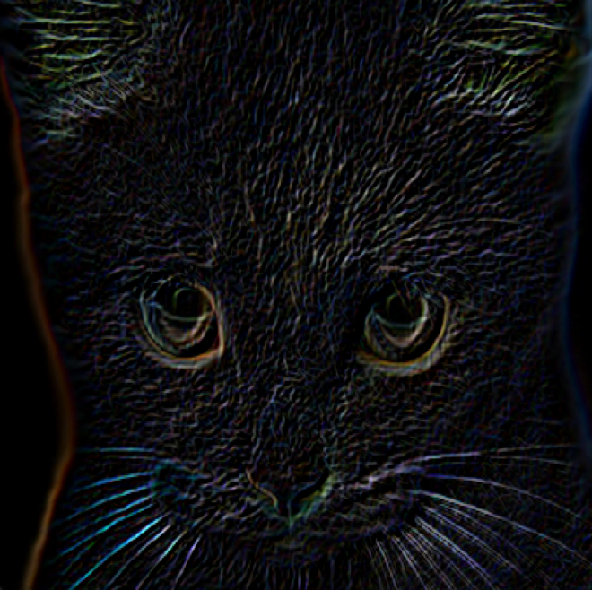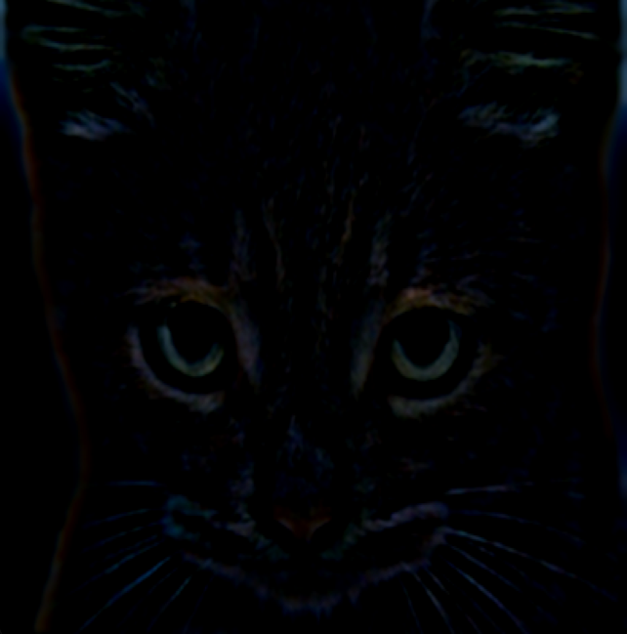

Sobel DOG

Compared the four pictures, I think that the suggested picture is the best. First, we can see the picture of LOG. The cat is made from bounds of short line. There is not outline for the cat. Therefore, some values are lost in this solution. Second, the suggested picture is pretty good. The color is even and we can see some detail from this picture. Third, we can recognize that the image is to strong and colors are brighter, although it is clear. And the picture is not consistent. Finally, even though the image is kind of consistent, it is so dark and some values are lost in this solution. In the center, it is clear, but image around the center is unclear. Therefore, the suggested picture is the best.

Readme:

I use the Clion software to code. I made three classes which are Guassian.cpp, Filter and Tools. The first two classes are easily understood. I use them to do my part two assignment. The Tools class is used to make show pictures in screen and make offset for a picture.

The operation is easy. Just write the path for low image and high image. And then click run. You will see the pictures of part one, two and three in the order.